Students are required to create a website that contains 3 pages (including the Home Page).  
The goal of the Multi-Page Website assignment will be to guide the students through producing a working multi-page website using the techniques taught during the course.

**Objective:** You are tasked to design and develop a website for a money lending company called SG Money Lender. The objective of the website is to generate leads.  
  
**Background:**  
We are a professional moneylending / credit company specializing in

1. Personal Loans
2. Business Loans
3. Foreigner Loans
4. Education Loans
5. Medical Loans
6. Wedding Loans
7. Vacation Loans
8. Renovations packages

Our company was established with a vision of providing competitive credit services to the public.

We pride ourselves as an alternative for loans from the banks.

Customer satisfaction is our main priority and service excellence is what we believe in.

With our beliefs, we are confident that we will be able to assist you professionally in providing a suitable loan solution which specially caters to your needs

Reference Website:

* <https://www.credit21.com.sg/>
* <https://apcredit.sg/>
* <https://ucredit.sg/>

**You are to submit a Creative brief with all the 3 links included in your website and a zip file containing the html and assets file**

**Please include your team names and contact details.**

**Additional Information**

1. **Bootstrap Framework is allowed**
2. **Favicon is required**

**Creative Brief**

*This is* ***responsive*** *Website built is adaptive to* ***desktop, tablet and mobile*** *and running live for demonstration purpose.*

* “SG Money Lender”
* Objective: Generate leads
* Different plans
* Minimize the process to load money

Web design Strategies: (From **Neil Patel**)

1. Remove all the options in the scrolling navigation other than “apply button”

（This will minimize wrong clicking, and increase chance of clicking the “profitable buttons”）

1. Make the text in the large paragraphs easy to read.
2. Reduce the footer navigation options
3. Add call to action within each section.
4. Landing Page
   1. Quiz visitors: How many he needs, what occupations

🡪 We recommend BEST plan (customization)

Then, to see the plan, visitors have to add their email into my database

* 1. Show the progress bar.
  2. Add signage: Loan in 5 minutes

**(Important section should enjoy full page for itself + one call for action)**

1. Headline rules
   * 1. Numbers and negative words increase CTR (Click-through rate)
     2. Keep them under 65 characters for search
     3. Make your headline match the content
     4. Odd numbers perform better than even
     5. Aim for 6-word headline
     6. Avoid words with multiple meanings
     7. Include power words and objectives
2. If someone stay too long, ask them a question
3. Answer objections
4. Add Paragraph:

Interesting fact: Did you know that personal, business, bank loans could have interest rate as high as 10%, 5% and 4.5% respectively?

We are a highly competent and efficient team. This allows us to provide loan services with interest rate at least 80% less than personal loans and at least 50% less than most local banks. We probably provides the BEST deals across the whole Island.

(Cost Difference)

1. Different plans for every category, especially educational load

(Slogan: Education is expensive, but it will give you a brighter future. We understand your needs while studying. Hence, there will be 0% interest during your candidature period, and repayment and interest only starts 6 months after graduation.)

1. Let people know that it is easy to loan money from us.
2. Show we are credible with our words (Show partnership with well-known companies: Tencent, Google, Microsoft + reviews from past users)
3. Consider creating short video explaining the process instead of the image in the top left.
4. What’s the catch, Why is it FREE.
5. Show EMPATHY and WIIFM (How we could help them and what stand to lose if not accepting our offer.)
6. Arrange in level of importance:
7. Personal Loans
8. Business Loans
9. Wedding Loans
10. Education Loans
11. Medical Loans
12. Renovations packages
13. Vacation Loans
14. Foreigner Loans

Marketing Strategies and slogans

* 1. TARGET AUDIENCE: Students, small business, anyone who may need to following services

1. Personal Loans *— We understand life could be tough sometimes. So, we would like to give a helping hand.*
2. Business Loans *— Businesses don’t always run smoothly, and you may just need that extra fund to power it to the next level.*
3. Foreigner Loans *— Life in a totally new environment could be tough, we are here to relief some of your stresses.*
4. Education Loans *— Having a good education ensures brighter future. We could help you to study with a peace of mind. No interest collected during the education period.*
5. Medical Loans *— Life is full of surprises and miracles. We are just here to relief some of your stresses.*
6. Wedding Loans *— Congratulations! We are glad to provide some help in building those long-lasting memorable moments in your life.*
7. Vacation Loans *— This is a wonderful world. Explore it with your beloved ones without worries on budget.*
8. Renovations packages *— Your productivity and fruitful journey starts from a warm and lovely home — we are an enabler to better homes.*

Vision: Our Financial Loan Could Help You Get Through Tough Tides At MINIMUM Cost.

Slogan: Breaking Through Tough Tides With You

* 1. Explain why they need money (Create “needs”)
  2. Make borrowing money from ME good, less worry and legal.

( 3-Day Cool down period:

If you change your mind or you no longer need that much cash.

We provide Money-Return Policy (MRP) * at NO cost.

Smaller font:

We welcome you to let us help you with your financial difficulties. However, we also understand that your needs may change. Hence, we are providing 3-day Money-Return Service without any charges or penalty, so that you could borrow what you need at Zero-Risk.

In prevention for Money-Return Service abuse uses, every customer is limited to 2 returns annually.

Build Credibility: show license no. (License No. XX/2021)

Example:

Fortune Credit Pte Ltd is a licensed moneylender (License No. 31/2021) listed in the Registry of Moneylenders, under the Ministry of Law in Singapore.

Sample:

SG Money Lender is a licensed moneylender (License No. 31/2021) listed in the Registry of Moneylenders, under the Ministry of Law in Singapore.

(This is a school project. Everything shown is for educational practice only.)

**Designs**

Logo Design



Thoughts behind the logo design:

1. The light- strike symbolizes loans from us could be done in lightning speed.
2. Colour Cyan blue: Symbolizes trust, security, and loyalty, conveys the message of support, confidence, peace, reliability, and honesty.
3. Message “Love Living, Worry Less” is the vision and mission of our company. We provide money lending service to people for them to have better living and less anxious about the stresses in life.

Colour palette

Centred around blue.

Web Performance

1. Reduce the number of fonts as every new font will increase the cost of downloading our page. SO, minimize the number of fonts to be downloaded.
2. Some overly large (more than 1280pixel) images have also been downsized and optimized by cloudconvert.com from PNG/JPG to WEBP for lighter loading.
3. Search Engine Optimized

**References:**

Videos on web design strategies: <https://www.youtube.com/c/NeilPatel>

Images retrieved from <https://www.loancfi.com.sg/services/personal-loan-singapore/>





Images retrieved from <https://www.fortunecredit.com.sg/monthly-installment-loans-singapore/>



Images retrieved from <https://cashmart.sg/maybank-personal-loan-in-singapore/>

Images retrieved from <https://financeguru.sg/how-to-optimise-home-loan-refinance/>



Images retrieved from: <https://holbornassets.com/blog/financial-planning/guide-to-financial-freedom/>



Images retrieved from: <https://galaxycredit.com.sg/six-things-no-one-tells-you-about-getting-a-fast-loan-in-singapore/>

Images retrieved from: <https://vulcanpost.com/666288/singapore-student-entrepreneurs-8-startups/>

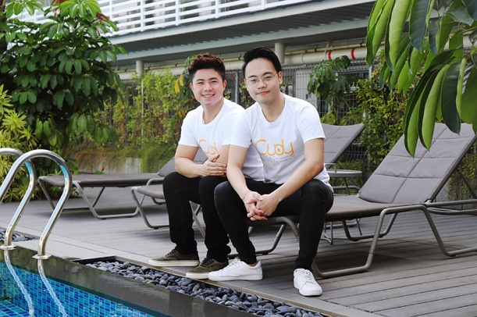

Images retrieved from: <https://r2dcredit.com/personal-loan/>



Images retrieved from: <https://www.istockphoto.com/illustrations/cartoon-of-a-personal-loan>

